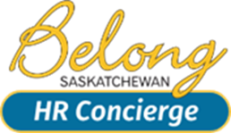

LETTER OF EXPECTATION
TEMPLATE #2

Sally Jones

March 12, 2024

Re: Performance/Behavior

- Overall attitude and general demeanor have grown increasingly negative over the last six months.

Culminating Incidents

During the last week, several instances have occurred that are considered inappropriate.

- Comments made during staff meeting re: Christmas Holiday days.
- Inappropriate involvement in another department re: scheduling of daughter’s hours in catering.
- Discourteous tone and manner (negative) used in the office environment with fellow staff.
- Not following proper procedures re: Inappropriate registration for off-site classes and subsequent negative attitude.

As these concerns have been broached previously in an informal manner, this letter is to serve as notice of expectations of future conduct.
- A courteous tone and manner will be used at all times with fellow employees, supervisors and clients.
- Discussions of a personnel nature (Jerry and Bettys’ schedules and working hours) are not to occur at the workplace.
- All feedback of a negative nature will be directed to your manager exclusively.

Any further inappropriate behavior will be considered unprofessional conduct and will warrant a written warning or suspension.

Bob Jones____________________ Date: ____________________

Cc. Employee file

